Cardigan House – Re-occupation Proposal for Social Distancing

Note: All social distancing, hand sanitisation and local risk assessments will be the responsibility of the staff. Support and advice can be provided by the School if required.
Cardigan House, Heath Park, Cardiff CF14 4XW
Aim: Ensure the safety of all staff within Cardigan house

Focus: Introduce a give-way system of movement around the 2nd floor to provide the users with the ability to maintain the required 2m social distancing. Ensure sufficient means of cleaning and sterilising hands and surfaces to reduce risk of contamination.

Entry & Exit:
There are two entrances to Cardigan House. Normal open access times are 08.00 – 17.00. Staff & students also have PAC access between 07.00 – 08.00 and 17.00 – 19.00.
As this building is shared by the UHB and we cannot dictate flow of traffic, we propose access as normal, via the tunnel doorway or the University PAC doors, both on ground floor. There is an option of the stairs or lift to the 2nd floor. Face coverings should be worn at all times unless social distancing can be adhered to. Fire exit doors should not be used to enter the building. A University ID card will be needed for identification and to access during out of core hours.

Floor 2
We occupy 15 offices on the 2nd floor, from 2F12 – 2F25 as below. Traffic flow will be give way and signage will dictate this. Staff will adhere to their local risk assessments when located within their offices.

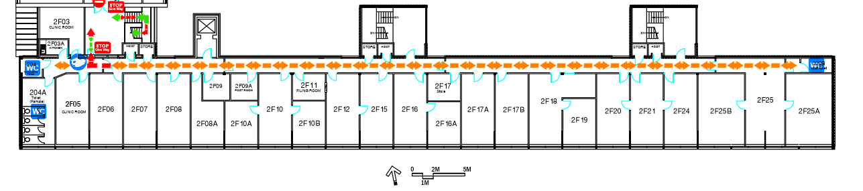

Signage:
Directional wall and floor signs to clearly show give-way only flow of traffic (See plan). Social distance signs will also be installed to ensure compliance throughout the floor.

Lift:
Use of stairs will be encouraged. The lift will run as normal but we cannot enforce single user only due to shared occupancy.

Toilet Facilities:
Toilet facilities will be single user only, due to the difficulties of social distancing within the space. Additional external toilets (for compliance, dependent on user numbers, if required, will be evaluated, potentially with hired portable toilets located at Heath Park).

Kitchen use - Water & Food:
Kitchen use will be discouraged but will be a single use only.

Offices:
Introduce social distancing measures by encouraging single use and reconfiguring desks where possible etc. However, this density will be measured via local risk assessment.

Hand Sanitiser:
The 2nd floor will have a sanitising station fitted at the main entrance of the floor with (See sanitisation plan).

Outside Normal Hours:
It will be encouraged to minimise accessing the building outside of core hours (Monday to Friday 8am-5pm). Adhere to Out of Hours Building Policy as per safety induction.

Peak Access Periods:
Work at home if possible.
Start and end of day: Set staggered start & finish times where possible

General Information:
General advice and guidance will be disseminated electronically as necessary. Please be familiar with advice posters located throughout the building.

