COVID-19 building risk assessment – Haydn Ellis building.
Covid-19 is a new viral illness that can affect your lungs and airways. Symptoms vary and can be mild, moderate, severe or fatal.
This is a COVID-19 secure building risk assessment for Haydn Ellis Building for dealing with the current Covid-19 situation in the workplace. Using the principles identified in the Cardiff University Organisational COVID-19 risk assessment, this assessment highlights the hazards linked to COVID in this building and identifies local appropriate control measures to ensure, as far as practicable, a COVID-secure workplace is maintained.
This assessment is supported by the overarching ‘Building Reoccupation Proposal for Social Distancing’ and ‘Building Re-Occupation and Re-use Pre-requiste Requirements and Assurance Checklist’ documents which set out operational detail.
A schematic representation of the management of the movement of people per floor of the Haydn Ellis Building can be found in Appendix 1. (Internal access routes)
The building access procedure for the Haydn Ellis building can be found in Appendix 2

What are the hazards? | Who might be harmed | Controls Required | Additional Controls | Action by who? | Action by when? | Done
Contraction and spread of Covid-19 Coronavirus.  Staff health and wellbeing related issues associated with working remotely. | Staff, students, visitors. | The following sections outline the current controls. | The following sections outline additional controls.
 | Control of building access and movement of people
 | Staff, students, visitors.  Hadyn Ellis Mental Health Clinic (staff and patients) | PAC control of building access in place managed by Security. Only authorised staff, students and Contractors are able to work onsite.  Access requests are managed by the School and on site Professional Services management (IT / Estates).  - Core hours 08:00 – 18:00 Monday – Thursday, 08:00 – 17:00 Friday. (All staff must use the designated entry and exit points.  - Entry & Exit: We are proposing to designate the door on the end of the building facing CUBRIC (next to the DRI Lab) as ENTRY and EXIT. The side accessible door will be the entry route, with the rotating doors as the exit route.  - During core hours (08:00 – 16:00 (from Monday 5 October 08:00 – 18:00) Mon – Fri), the fire exit behind the main stairwell will be used as an alternative exit route. This will not be available out of hours.  - Other times: (18:00 – 08:00 Mon - Fri / All day Sat / Sun / Public holidays): Out of hours/periods of minimal occupation a designated 24 hours door is to be used. This is the side accessible door on the CUBRIC side of the building (by the DRI Lab).  NB – core opening hours is subject to review.  - Sanitising gel (alcohol and no alcohol based gel) will be available for use upon entry and exit  - Reception services are on site 08:00 – 16:00 Monday to Friday to ensure social distancing and hygiene requirements are met within reception.  - Building Facilities Manager is on site weekly to spot check Covid Safety arrangements in general / circulation areas.  - Security Services are available 24/7 to assist with any security / safety concerns  - Internal doors may be removed or held open only when formally identified through fire risk assessment process, and only where safe to do so.  - Building access no earlier than 8am, Monday to Friday (in line with cleaning and hygiene protocols below).  - Essential/Research Staff will continue to have extended access provided in accordance with School / Department requirements and local risk assessments. Out of hours access is determined by reception closing times. Currently 18:00 – 08:00 Mon – Fri and at weekends and public holidays. Safezone app is recommended for automated check in. Insert local out of hours arrangements*  - All occupants to display their University ID card.  - NB: Children not allowed into University buildings until further notice.  Hadyn Ellis Mental Health Clinic  The mental health clinic is currently open for telephone appointments and will start face to face patient appointments from 25 November 2020.  Opening hours – The main entry doors will be opened by the Hadyn Ellis reception team from 08:00 – 17:45 Monday – Thursday and 08:00 – 16:45 Friday. The reception team will be directed by clinic staff if reduced opening is needed.  Entry – Patient entry is via the clinic main entry door located at the south side of the building, opposite the Optometry building.  Staff will enter via the internal pac access door. Every precaution should be taken to ensure the area is clear or there is a minimum 2m distance prior to entering this door.  Exit – All persons will exit the clinic via the internal pac door.  Patients will be directed to leave via the double glass doors at the back of the atrium, staff can exit as per building covid safety measures (exit via the car park side of the building).  A common sense approach should be adopted when leading patients out of the building to ensure their safe exit.  Safety measures  Covid safety signage is in place throughout the clinic.  Patients will be seen by appointment only.  On arrival, patients will wait in the lobby area where hand sanitising equipment will be available.  A one way route is in place throughout the clinic.  Social distancing seating has been set up in the reception area and treatment rooms. Details will be issued to staff prior to entering the clinic via the clinic staff covid induction document.  Perpex screens at the reception desk will be in place prior to patients arriving. If this is delayed, staff should take every precaution to maintain a 2m distance.  Hand sanitising stations will be available as well as ample hand washing facilities.  All toilets in the clinic are gender neutral and capacity for 1 person only.  Clinic / task risk assessments will be in place for clinical staff. All clinic staff should familiarise themselves will all relevant documents prior to working on site. | Local management to ensure that staff, students and visitors receive a building induction covering related significant risk, and understand the necessary critical/ building-specific control measures.  Hadyn Ellis clinic staff induction doc  Hadyn Ellis clinic patient information doc  Local risk assessments and operating procedures
 | CovId testing Centre visitors and staff | A Covid testing centre will be in situ in the Hadyn Ellis Building exhibition area from 08:00 – 18:00 From Wednesday 30 September 2020.  Core hours – The testing centre will be open from 08:00 – 18:00 Monday – Thursday.  Entry / Exit - The designated entry & exit route for the Covid testing centre will be the Maindy Road entrance. The side accessible door for entry and rotating doors for exit.  - The Hadyn Ellis reception team will open and secure the doors in line with the Covid testing centre opening hours. Alarms will be set once the doors are locked.  - The testing centre is screened off from the rest of the building.  - Testing centre staff and visitors are permitted to use the toilet and coffee shop facilities. For access, they will need to exit via the Maindy Road doors and re-enter via the doors at the CUBRIC side of the building. Access is only permitted for short stay to use toilet facilities and / or to use the takeaway coffee shop service.  - The Covid Testing Centre has a separate risk assessment for operational purposes. | Covid Testing Centre risk assessment and operating procedures
 | Physical distancing in the workplace – Cleaning and hygiene
 | Staff | - Staff access begins at 8am to give cleaning staff time to clean and sanitise key areas before staff enter.  - Touch points and heavily used areas will be prioritised for repeat cleaning throughout the day.  - Toilets/kitchenettes will close for short periods during working hours for additional cleans to be carried out.  - Sanitising stations will be provided by Estates at entrances and key circulation areas (lift entrances / reception desk).  - Hand washing facilities are available on each floor in toilets and kitchen areas.  - Specific risk assessments and protocols for cleaning processes in place.  - Where it is not possible for cleaning staff to clean shared / hot desks between uses, sanitising wipes will be provided by the School..  - Maximum occupancy limits for offices, other work areas and refectories established and publicised.  - Where face to face meetings cannot be avoided, consideration should be given to them being held outdoors with appropriate physical distancing in place. Where this is not possible meetings should be held in well ventilated rooms. The number of staff physically present will be limited to essential members only. | COVID-19 building risk assessments communicated / available to all occupants.  Work groups to draft task specific risk assessment taking account of, and in support of, the building risk assessment.  Staff to be reminded through briefings and posters of the importance of physical distancing both in the workplace and outside of it.  Management checks to ensure the above controls are adhered to.  Statutory maintenance requirements identified for each building. Task specific risk assessments drafted and communicated.
 | Physical distancing in the workplace – Defined routes/ lift access
 | Staff, students, visitors | - Signage in buildings placed at strategic points reminding of two metre social-distancing requirement.  - In corridors where queues are likely to form (e.g. outside kitchen areas, toilets etc.), floors will be marked with two-metre distance reminders. (NB – the 2m signage is not spaced 2m apart but is there as a reminder to keep the distance).  - All occupants to follow new route signs stipulating up, down, Keep Left, etc. (please see - Appendix 2 Building Reoccupation Proposal for Social Distancing Building access procedure’ ).  - Lifts will be recommissioned, but occupants asked to use stairs where possible. Lift priority given to disabled people, or for the transport of large/heavy/hazardous materials where use of stairs not possible or safe.  - If lifts must be used, staff are advised to avoid touching lift call buttons, instead use pen, elbows, etc, to operate, and limit occupancy to single use only.  - Staff with accessibility requirements should contact their line manager about suitable working arrangements ahead of return and discuss updating their Personal Emergency Evacuation Plan (PEEP). | Estates mark out the travel routes throughout the buildings and put up information posters.
 | Laboratories and ARCCA
 | Staff, students | - Local task-based risk assessments reviewed in line with current government guidance and sector good practice.
 | Lecture theatres, seminar rooms and managing meetings
 | Staff, students | - Lecture theatre has a one way route with designated entry and exit route. The route into the lecture theatre is via the left side glass door. The exit route is via the back corridor and out through the right side door. A safety screen will separate the entry / exit route.  A procedure will be required for the exiting of the lecture theatre while still maintaining social distancing. e.g. vacate one row at a time to re-join the one-way corridor.  - Digital solutions will be the default method of meeting to limit face to face meetings and maintain two metres distance from colleagues.  - Not every desk will be able to be used every day therefore office occupancy capacity will be assessed after physical distancing rules are implemented. This is the responsibility of the relevant School / Professional Services department.  - Local directional signage in place to ensure safe routes are indicated.  - Staff and students are expected to take responsibility for any workstation they use including wiping down surfaces and shared equipment after use.  - Workstations and desks will be arranged with a minimum separation between them – where necessary screens will be fitted including reception desks. This is the responsibility of the relevant School / Professional services department.
 | Welfare facilities
 | Staff, students, visitors | - All toilets have be changed to gender neutral / single occupancy use, with a lock on the external door.  - Toilets on the ground floors: Entry to ground floor toilets will be via the coffee shop. The route is identified on the flooring. Each toilet will be gender neutral / single occupancy. There will be a queuing system in place which will fall into a designated area in the coffee shop with 2m distancing floor signage. The exit from the toilet will run along the main corridor (leading from all toilets). Care should be taken by the individual to ensure a 2m distance is kept when exiting this corridor. Screens are in place along the queuing location, and an to separate the queue from the coffee shop area.  - Toilets to Upper Floors: All toilets have been reassigned to gender neutral and single user only. Where possible, there is only be one-way movement along the route outside the toilet facility. Where this is not practical, signage will be in display to remind occupants to keep a clear 2m distance when entering / exiting the toilet, and if queuing is needed.  Corridors are not wide enough for one way route screening on the 1st, 2nd and 3rd floor toilet locations.  4th floor toilet is for the use of JBIOS staff only, due to the sensitive nature of the location. in the corridor to allow for a queuing point.  - Locks have been fitted to outer toilet facility door to secure any multiple facility that is now only suitable for a single user.  - If required, a floor standing screen will be fitted in the vicinity of the toilets to enable queuing while still maintaining a route for passing users on the one-way route along the corridor. This is not applicable at the moment, but may be reviewed if the current arrangements prove insufficient. | Estates to action
 | Infection control
 | Staff, students, visitors | - Notices will be displayed reminding staff and students of the key infection prevention requirements.  - Respiratory hygiene: Staff and students are required to wear face covering whilst inside the buildings where this does not contravene the local risk assessment. | Employees reminded on regular basis to wash hands for 20 seconds with soap/water, and dry with disposable towels. Also to catch coughs and sneezes in tissues, (‘Catch it, Bin it, Kill it’), and avoid touching face, eyes, nose or mouth with unclean hands. Tissues made available throughout the workplace.  Encourage staff to report any problems and carry out skin checks as part of a skin surveillance programme  https://www.hse.gov.uk/skin/professional/health-surveillance.htm  To reduce the spread of COVID-19 remind everyone of the public health advice - https://www.publichealth.hscni.net/news/covid-19-coronavirus  Posters, leaflets and other materials are available for display.  https://www.gov.uk/government/publications/guidance-to-employers-and-businesses-about-covid-19
 | Catering and communal areas
 | Staff, students, visitors | - Staff and students encouraged to bring their own water bottle, and eat food outside if the weather permits.  - Arrangements for use of communal kitchens will be made on an individual basis dependent on size, location, accessibility with clear occupancy levels indicated operating a ‘one out one in system.  - Coffee shop will be open, with appropriate safety measures in place. Details of these are to be confirmed and will be covered in the catering risk assessment.
 | Working onsite – Deliveries and drivers
 | Visitors, staff, students. | - Deliveries:  - Mail is delivered by Cardiff University Mail Room Porters. Mail is delivered to the reception team. A Perspex screen is in place at reception. A designated safe area on the reception desk is available for safe deposit. Cleaning spray and wipes are provided for the reception team and visitors.  - Courier deliveries are made daily. A delivery drop off point is in situ. Access is via the gate intercom for large deliveries.  - Large / lab sensitive deliveries – will be delivered via the compound area. Lab staff will be notified and will attend (with social distance measures in place).  - Other visitors – engineers / contractors – access for engineers / contractors is only granted if advanced notice and authorisation has been arranged.  - Other general visitors are not permitted in the building during this time. | Reception services have the following measures in place for the safety of staff and delivery persons:  - Perspex safety screen covering reception desk.  - Hand sanitisers at the reception desk  - Drop off point for deliveries
 | Emergency preparedness
 | Staff, students | - Fire risk assessments completed before reoccupying the building.  - Campus Patrol Officers are available on campus 24/7 (but in reduced numbers).  - In the event of an emergency building evacuation, occupants must use their nearest safe exit point, regardless of any COVID-19 specific signage or routes. Prompt evacuation will take priority over social distancing considerations. At assembly points, staff should take every care to maintain physical distancing whilst being within visual sight of any Fire Wardens.  (Please note: Initially few trained Fire Wardens are likely to be present, so evacuate immediately, do not await instruction).  - Under no circumstances should fire doors be propped open.  - Should staff feel unwell with potential COVID-19 symptoms whilst at work, they should contact a first aider, isolate in an office in the building and contact their line manager.  - Guidance for first aiders can be found here. For minor injuries such as small cuts, staff may be asked to self-administer if advised by a first aider.  - First aider and fire warden lists are being updated to ensure relevant personnel contact details are available to those on site. | Fire risk assessment completed and communicated prior to occupancy. | Safety and Staff Wellbeing

Appendix 1: Internal access routes
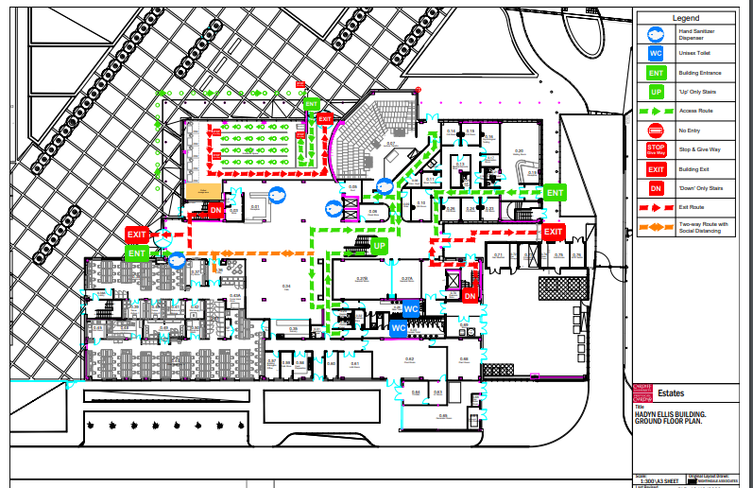

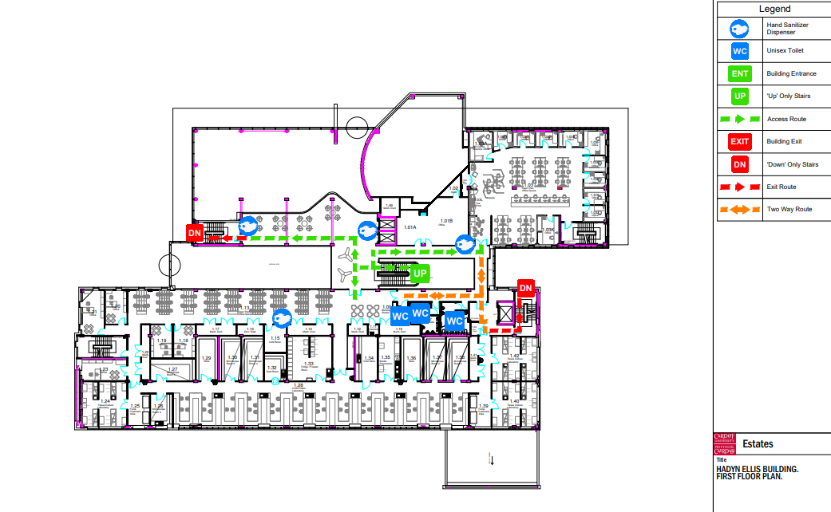
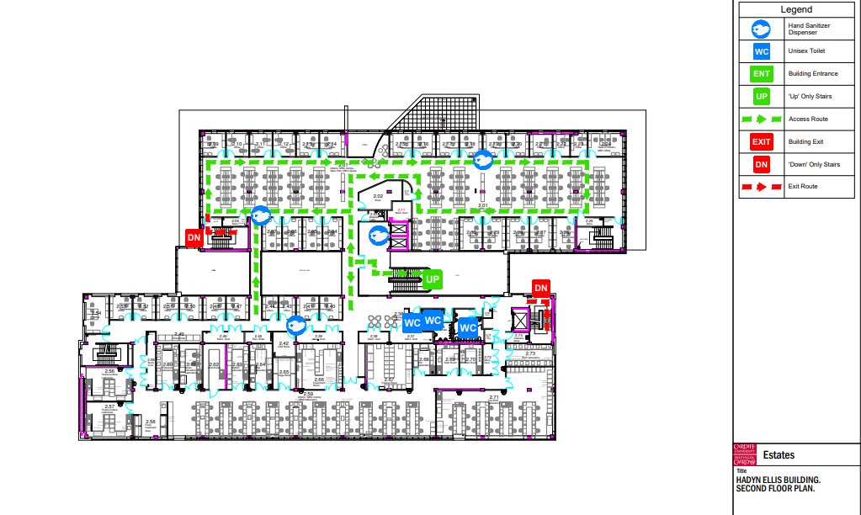
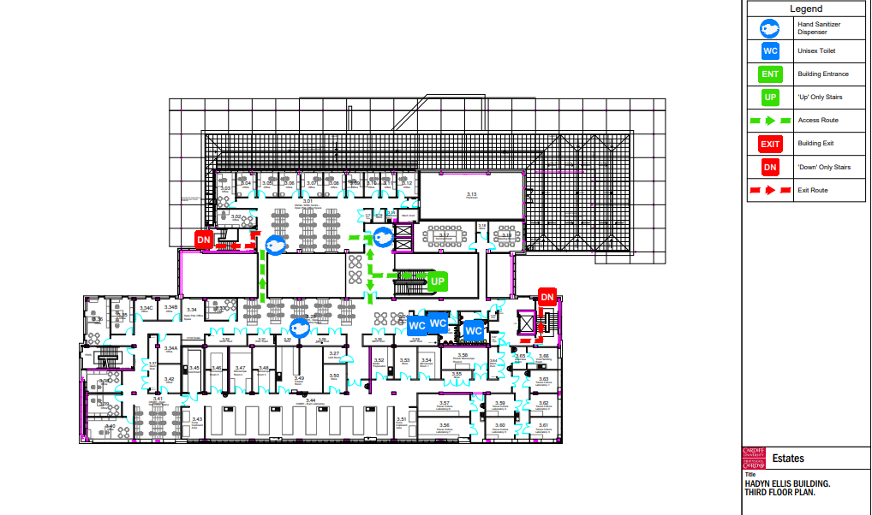

Appendix 2 - Building Reoccupation Proposal for Social Distancing (Haydn Ellis - Building Maindy Road)
Movement through the Building
We are proposing to introduce a one-way system of movement around each floor of the building to provide the users with the ability to maintain the required 2m social distancing by not having to return past other users.
Entry & Exit:
There are two main entrances to HEB. We are proposing to designate the door facing Maindy roadside as Entry Only and the other door on the end of the building facing Cubric will be designated as Exit Only. We have confirmed either door can be set for 24hr operation as required. Additionally, during core reception opening hours, the emergency exit at the back of the atrium (E009) will act as an additional exit route.
Reception Desk:
Reception area will require acrylic screens to all sides for segregation. These will be standing height screens and if a slot for passing items back & forth, such as keys is required, openings can be cut on site to meet the user’s individual requirements. This has been installed.
Lecture Theatre:
The lecture theatre has two entry points, where one will be designated as entry only and the other as exit only. Users will approach through the double doors off the main lobby area then enter through the first entry door on the left into the lecture theatre. Users will depart from the far exit point and turn right along the internal corridor back into the main lobby area. Social distancing will need to be observed as you pass in and out of the double doors off the main lobby. However, we are proposing to introduce standing screens to assist with two-way travel in this area.
General capacity of lecture theatres is estimated at approx. 16%.
This may require closing off every other row and taking every few seats out of use to enable 2m social distancing to be achieved.
Toilet Facilities:
Multiple user toilet facilities are being made gender neutral and single user only, due to the difficulties of social distancing within the space. There will be a requirement to fit locks to all outer doors. This has been implemented.

The main toilets on the ground floor are all along the same corridor, but we are proposing to create a short corridor within the seating area of the café for the entry and queuing point into the toilet facility. This will then enable users to exit via the toilet corridor out to the bottom of the main stairs without having to pass other users. This has been implemented.
Toilets to Upper Floors:
The toilets have been reassigned to gender neutral and single user only.
There will only be one-way movement along the route outside the toilet facility, where possible, but dependent on queuing issues we may have to introduce a screen in the corridor to allow for a queuing point.
Fourth floor toilet is for the use of JBIOS staff only, due to the sensitive nature of the location.
Routes by Floor:
Ground Floor: From the ground floor there are several emergency exits that could serve as exit points from the building, but due to the security risk of doors remaining open we are proposing to route users back to the main exit point within the access controlled areas and open an additional exit point adjacent to the rear staircase on the Optom side of the building.
To aid the exit routes and maintain security we are proposing to open a new doorway from the staircase at the rear of the reception to the lobby area to take users internally to the main exit point on the ground floor level rather than straight out through the emergency exit, which will minimise the security risk of any intruder trying to gain entry this way.
There is a clinic area that has external access from the roadway between HEB and Optom that should be able to social distance, but the corridor to the consultation rooms will need to exit in to the HEB main lobby and out through the additional exit point adjacent to the rear stairs as mentioned above.
1st ,2nd, 3rd Floors: There are several staircases that serve the three floors but again due to the security risk we are proposing to route users up the main staircase to follow a one-way system around each floor to access all areas and exit from the two marked staircases back down to the ground floor to leave through the two exit points on either end of the building. (The staircase behind reception will require the creation of a doorway back into the lobby area at ground floor level)
There are several cellular offices on these floors and the layout of desks in the open plan areas can easily allow for a one-way route around the floor.
We could achieve a larger number of users with the addition of acrylic desk screens, so desks can remain closer together.
4th Floor: There is only one staircase and goods lifting serving this floor. Entry & exit is slightly more problematic as there is a dead-end on the corridor with a few rooms off. However, as this area is restricted with a minimal number of users at any one time there should already be a protocol in place to deal with any cross-contamination risks, which may suit a procedure for safe movement around this space.
Staircases not marked as Exit Only: There is a potential to use these staircases to move one-way between floors and mark as either up to identified floors or down to identified floors but not outside through the emergency exit or through any controlled research areas.
Laboratories on all Levels: Acrylic screens could be used to create separate booths on laboratory benches. The screens can be fitted to the back of benches as well as in between each workstation to give all-round segregation whilst working on the bench. Laboratory departments have introduced their own specific safety measures, which are identified in their own department risk assessment.
Movement within Laboratories: Procedures will require input to ensure social distancing measures are in place. E.G. Only one user moves from any one lab bench at a time and users maintain social distancing as they move around the laboratory. Laboratory departments have introduced their own specific safety measures, which are identified in their own department risk assessment.
Note: Further guidance will be required as we could have individual booths along a bench. However, there is a potential issue if the user at the closed end of the bench moves out past the other users on the same bench, as this will encroach on the 2m ruling, unless other measures are acceptable, such as the wearing of face masks when moving around the space. Laboratory departments have introduced their own specific safety measures, which are identified in their own department risk assessment.
Additional External Toilets (for compliance, dependent on user numbers, See Note at end of document): If additional facilities are required, we will need to check drainage runs, power and water supplies to decide on the most suitable position.
There is a potential to install external shared facilities for use by both HEB and Cubric
Water & Food Heating/Welfare Space:
(different requirement for employees and student/public)
Water fountain/bottle filling points - All
The drinking water point on the ground floor will be accessible via a one way route (to the toilets)
Hot water points - Staff
Food heating points - Staff
Vending - TBC
Seating to consume food & drinks - Staff
To aid social distancing all the above could be within the Café area and additional seating could be in the main atrium area. The atrium (exhibition area) and first floor balconies have been set up to allow social distancing break areas. The walkway on the first floor balcony has been kept clear as an evacuation / exit route.

Study Space:
Currently discouraged to minimise users staying in the space but if a requirement we propose to limit numbers and move tables & chairs to provide the required 2m separation with possible floor marking around the furniture to discourage their movement.
Staff Kitchens: One user at a time with a queuing point and social distancing in the seating area. These arrangements are departmental specific, and identified in each departments own risk assessment.
Meeting and Seminar Rooms:
Procedure required for use of meeting and seminar rooms or reserve for over-flow office space/visitor use. (Would anticipate meetings would continue to be held virtually)
Quiet room
The quiet room is not available during this time. If quiet space is required, a request should be made to reception to check availability of seminar rooms. One person at a time only.
Capacity reduced to approx. 20%
Deliveries:
Porters bring deliveries through designated rear entry point. Install external phone/intercom for couriers. (Note there is an existing intercom on the rear roadway/gate access point)
Hand Sanitiser:
Dispensers x2 to front entrance (One alcohol based, one non-alcohol-based side by side)
Dispensers to entrance of lifts.
Dispensers in food/drink preparation areas.
All areas will have an even distribution of alcohol and non-alcohol based sanitising stations
Signage:
Policy and operational use of building to include emergency evacuation procedure.
Directional wall and floor signs to clearly show routes and permitted direction of travel.
Floor hatching at pinch-points to remind users to social distance
Queuing/social distance signs on floor at reception, toilet facilities, lifts, staff kitchens and outside main entrance.

Printers: Queuing points at printers with code set to data protect/retrieve printing. Follow me printing in operation. Departmental specific arrangements are in place.
Door Operation:
External pass doors and revolving doors are automatic.
Corridor Door/ Fire Doors: If required to minimise touch, fire doors can be fitted with fire alarm activated door-hold openers. (If not hard-wired, use Dorgard battery type holder)
Office, Meeting, Classroom Doors: Doors could be fitted with a device to avoid hand contact. E.G foot operated or forearm operated door handles.
General:
Face masks: Cardiff University has confirmed face coverings should be worn by all when inside CU buildings.
High Level Wall Mounted Display Monitors
Could be used to display latest information and COVID19 reminders such as the do’s & don’ts
Peak Access Periods:
Start and end of day: Set staggered start & finish times where possible.
Lunch times: Encourage staggered lunch breaks.
Outside Normal Hours:
Consider changes to door access outside of normal hours when reception is closed, and the number of users is lower. Entry and Exit to the building could be through the designated 24-hour door while still observing 2m social distancing. 2 x designated doors are assigned out of hours. Maindy Road for entrance / Car park side for exit.
Staff with Mobility Issues:
Designate space on ground floor for staff with mobility needs/PEEP’s to avoid use of stairs or lifts and mitigate against difficulties during fire evacuation.
Lifts:
Lifts will be signed to state if required for accessible access/movement of items, one user only, to discourage use to lower floors and fitted with external hand sanitiser to all floors. Service lift will be required for sensitive / lab movement. One person at a time.
Note, for Information:
Toilet facilities for employees
Staff 1-5 = 1 Toilet
Staff 6-25 = 2 Toilets
Staff 26-50 = 3 Toilets
Staff 51-75 = 4 Toilets
Staff 76-100 = 5 Toilets
Students/public 20 users = 1 Toilet.

